

**Module Code & Module Title**

**Level 6 – Application Development**

**Assessment Type 30%**

**Semester**

**2024/25 Autumn**

**Student Name: Sumit Pokhrel**

**London Met ID: 22085636**

**College ID: NP01CP4S230034**

**Assignment Due Date: Friday, January 17, 2025**

**Assignment Submission Date: Friday, January 17, 2025**

**Submitted To:**

**Word Count (Where Required):**

*I confirm that I understand my coursework needs to be submitted online via MST Classroom under the relevant module page before the deadline in order for my assignment to be accepted and marked. I am fully aware that late submissions will be treated as non-submission and a mark of zero will be awarded.*

Onedrive link= [22085636 Sumit Pokhrel.zip](https://islingtoncollegeedunp-my.sharepoint.com/:u:/g/personal/np01cp4s230034_islingtoncollege_edu_np/EafMSg4vcJpMrgfYeMiFrWUBBfbo57WYfoksHjaANhRcRw?e=oznIho)

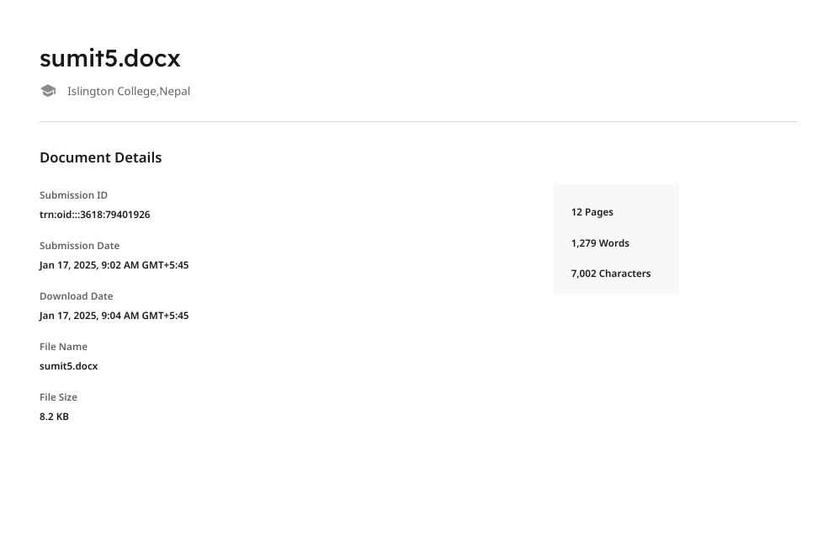

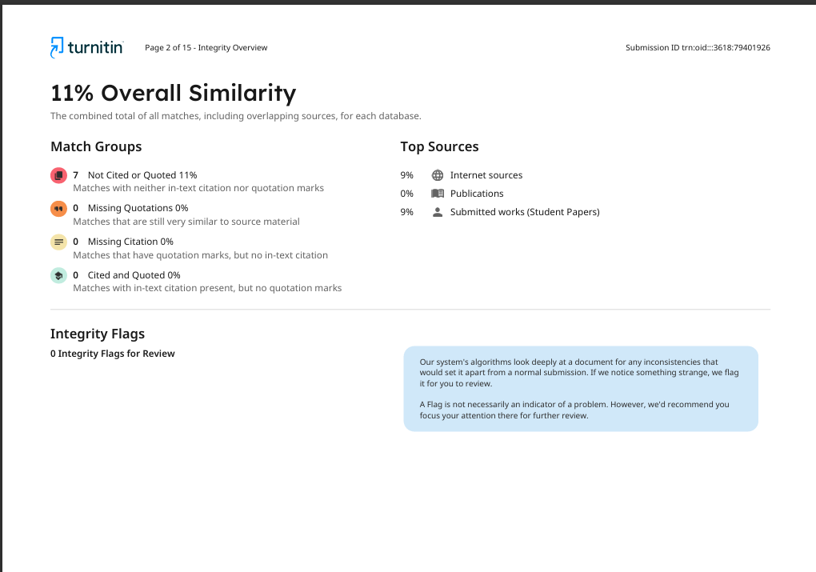

**Table of Contents**

1.Introduction 1

1.1Objective 1

1.2 Scope 1

2.Features and Functionalities 2

2.1.Login 2

2.2Home Page 4

2.3.Transaction List 4

2.4.Search by Title 6

2.5.Search by date range 7

2.6.Sorting date Desending 7

2.7.Sorting date Ascending 9

2.8.Edit Transaction 10

2.9.After edit Transaction 11

2.10.Debt Management 11

2.11.Add debt Transaction 13

2.12.Dashboard Financial Summary 13

2.13.Highest/Lowest Transaction 14

2.14.Top 5 Highest Transaction List and Piechart 14

3.Proof of Work(Pow) 16

3.1.Github 16

3.2.ERD 17

3.3.System Architecture 18

4.Individual Reflection(s) 19

5.Conclusion 20

**Table of figures**

Figure 1:Login Page 2

Figure 2:Filling up Login Page 3

Figure 3:Home Page 4

Figure 4:Transaction List 5

Figure 5:Search By Title 6

Figure 6:Search By Date range 7

Figure 7:Sorting date by Desending 8

Figure 8:Sorting date by Ascending 9

Figure 9:Click on edit button 10

Figure 10:After edit Transaction 11

Figure 11:Debt Management list 12

Figure 12:Add Debt Transaction 13

Figure 13:Dashboard Financial Summary 13

Figure 14:Highest/Lowest Transaction 14

Figure 15:Top 5 highest Transaction 15

Figure 16:Github 16

Figure 17:ERD 17

Figure 18:System Architecture 18

# 

# 1.Introduction

The creation and deployment of a C# desktop application that aids a Personal expenses tracker in maintaining its outflow, inflow and debt data is covered in this article. The project does not require a database or web-based application. This desktop program was created using the C# programming language and the Visual Studio Dot Net framework. The powerful, object-oriented, general-purpose programming language C# is pronounced "C sharp." Open-source C# is a simple, contemporary, adaptable, and multipurpose programming language.

## 1.1Objective

* Give users the ability to track and organize all of their revenue and spending transactions so they can see their financial status clearly.
* Let users keep tabs on payments, keep track of outstanding debts, and make sure they are meeting their financial responsibilities.
* To help users remain inside their spending restrictions, assist them in creating budgets for various expenditure categories and monitoring their spending.

## 1.2 Scope

* User Authentication
* Dashboard
* Debt-management
* Transaction List
* Add Transaction

# 2.Features and Functionalities

## 2.1. Login

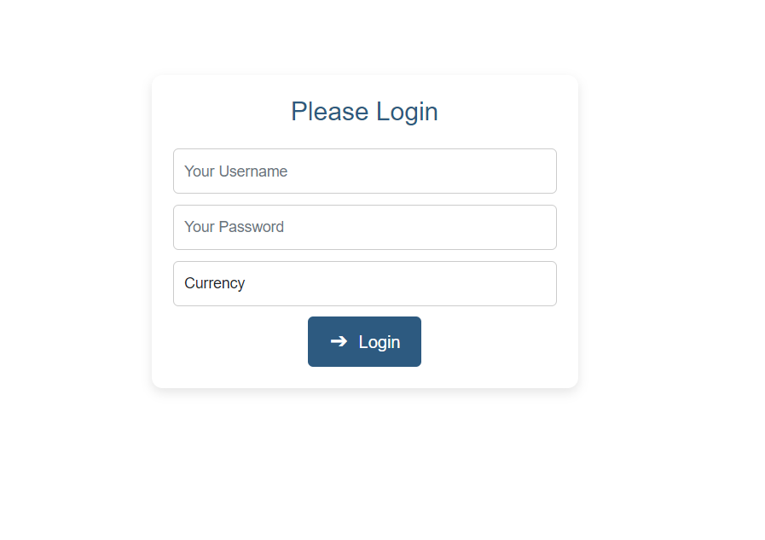

Figure 1:Login Page

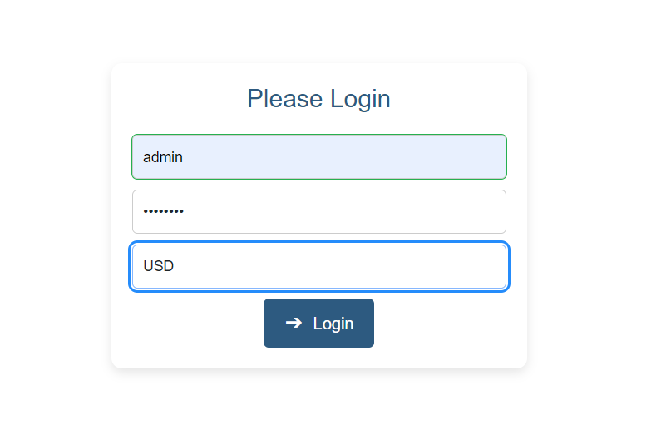

Figure 2:Filling up Login Page

The login form will initially display, where the user must input their username and password to access their dashboard. users should put their usernames in the username box and their passwords in the password field. After providing their username and password, the user may access their dashboard by clicking the login button. Username for User: - admin, Password for User:- Password.

## 2.2Home Page

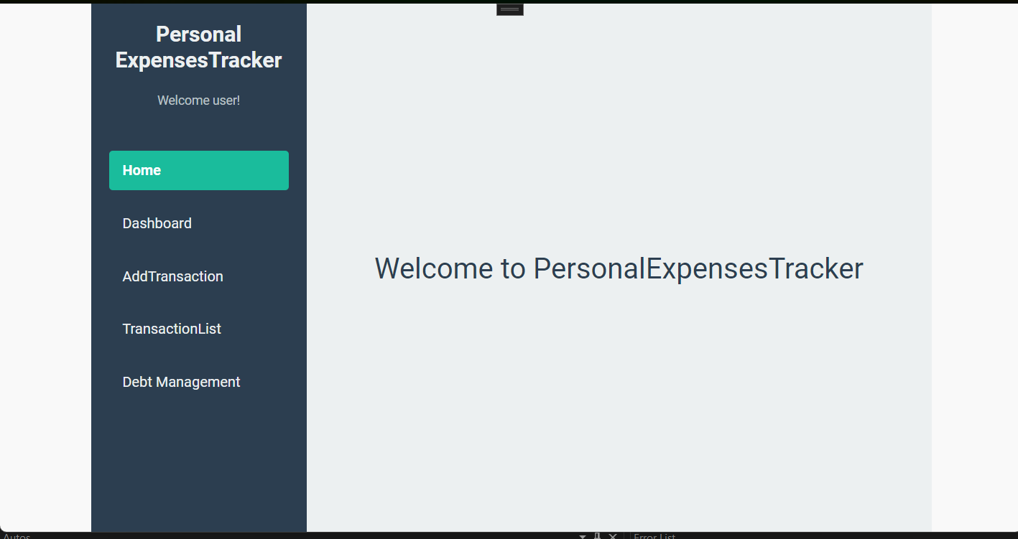

Figure 3:Home Page

After entering from login page, User will be able to see their respective Home page.

## 2.3.Transaction List

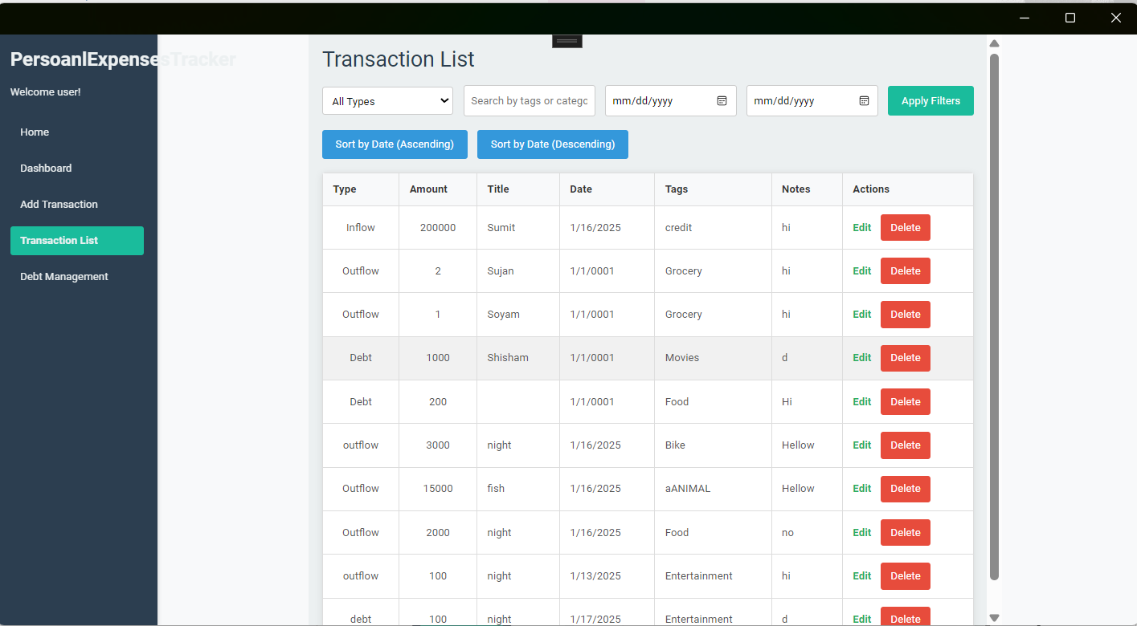

Figure 4:Transaction List

Here, User can view Transaction list ,edit transaction and delete transaction.

## 

## 2.4.Search by Title

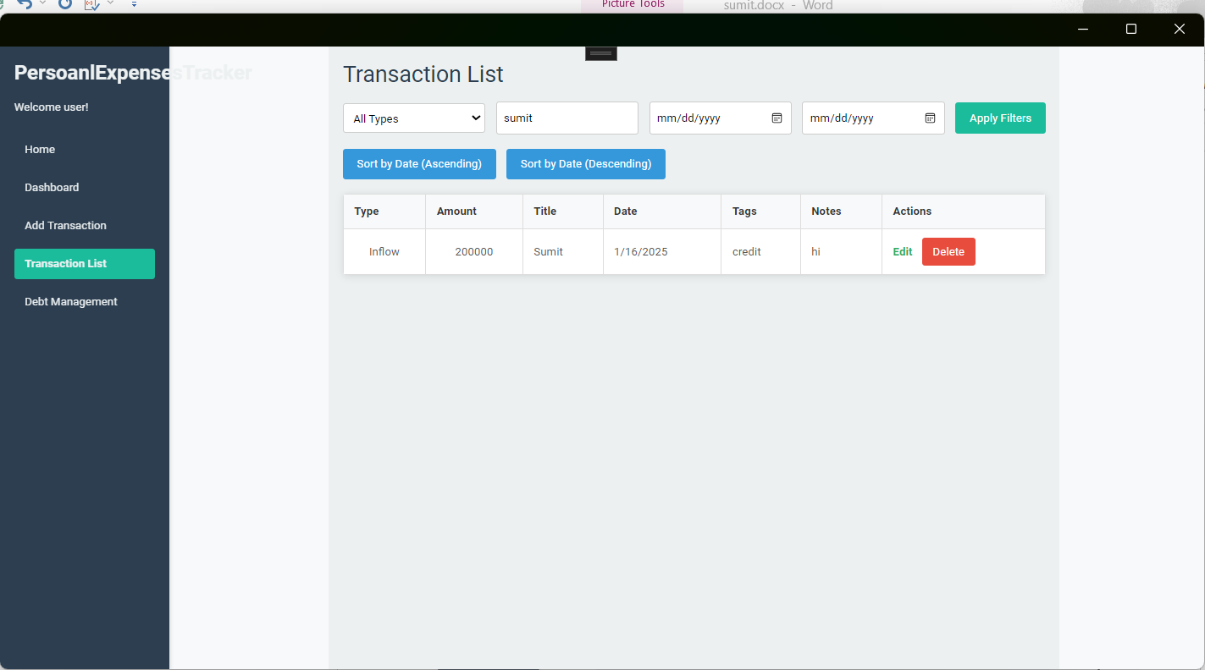

Figure 5:Search By Title

Here, User can search Transaction list by Title and Tags.

## 2.5.Search by date range

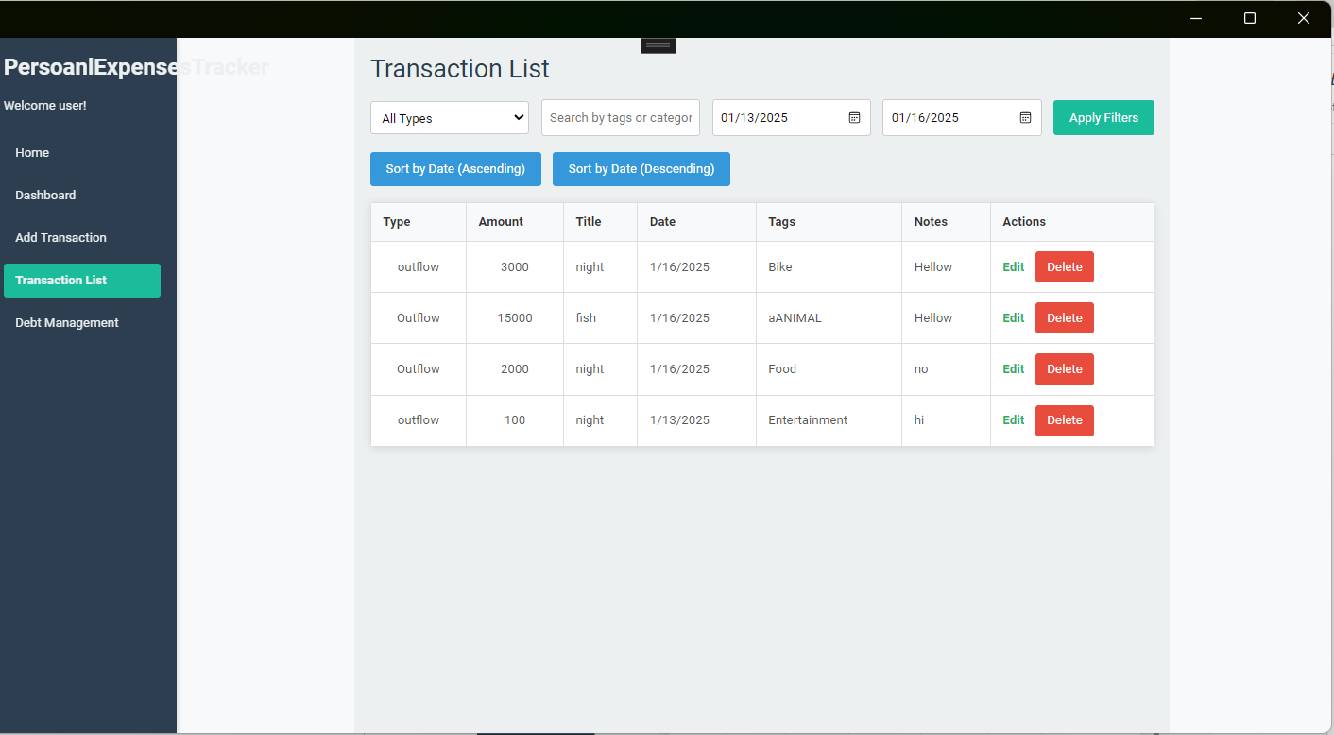

Figure 6:Search By Date range

Here, User can search Transaction list by date range.

## 2.6.Sorting date Descending

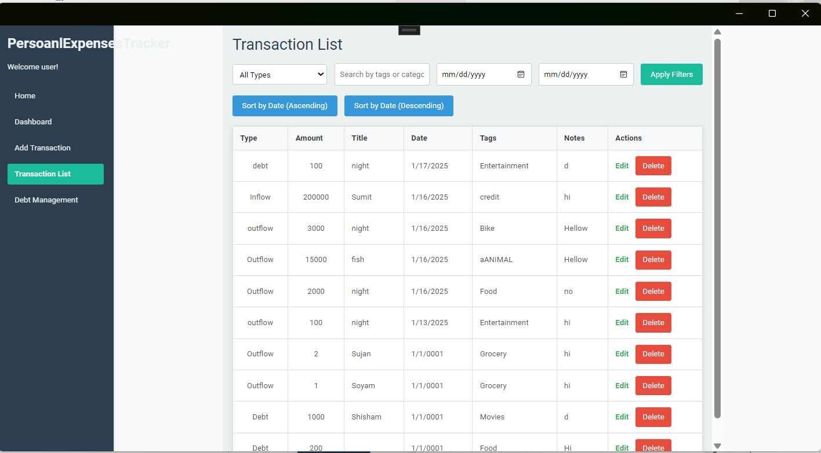

Figure 7:Sorting date by Desending

Here, User can sort Transaction list by sorting date.

## 

## 2.7.Sorting date Ascending

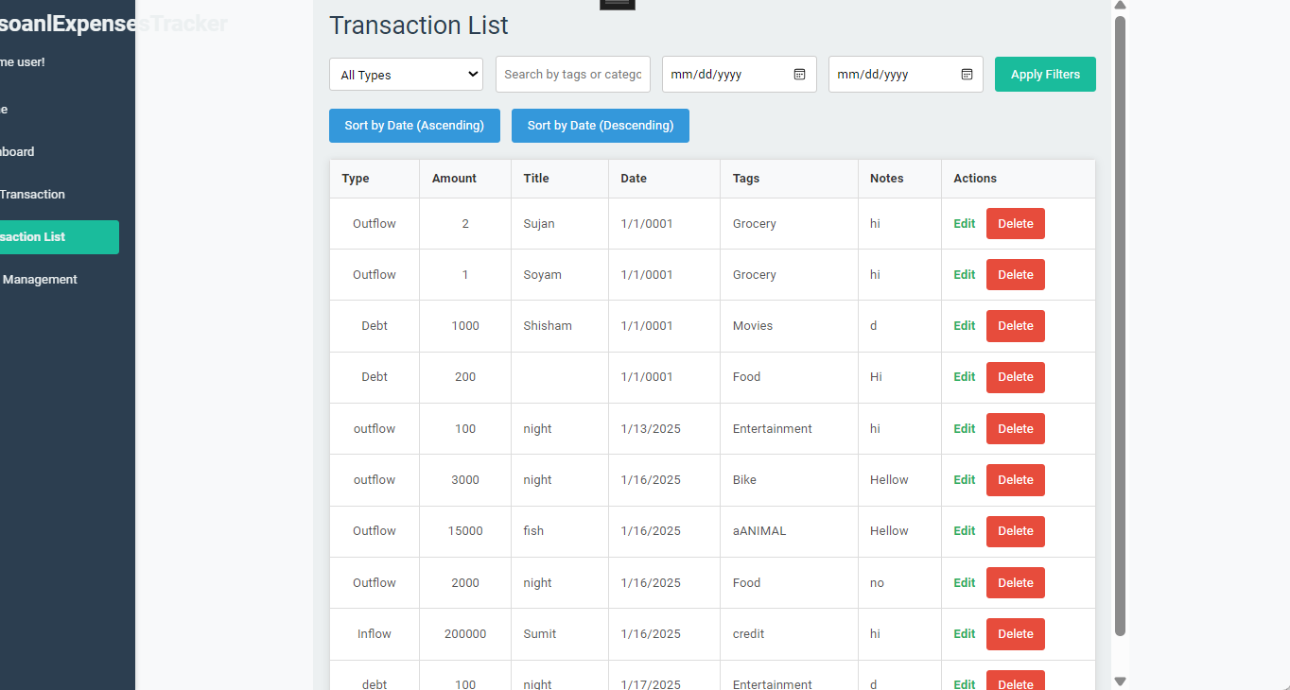

Figure 8:Sorting date by Ascending

Here, User can sort Transaction list by sorting date Ascending.

## 

## 2.8.Edit Transaction

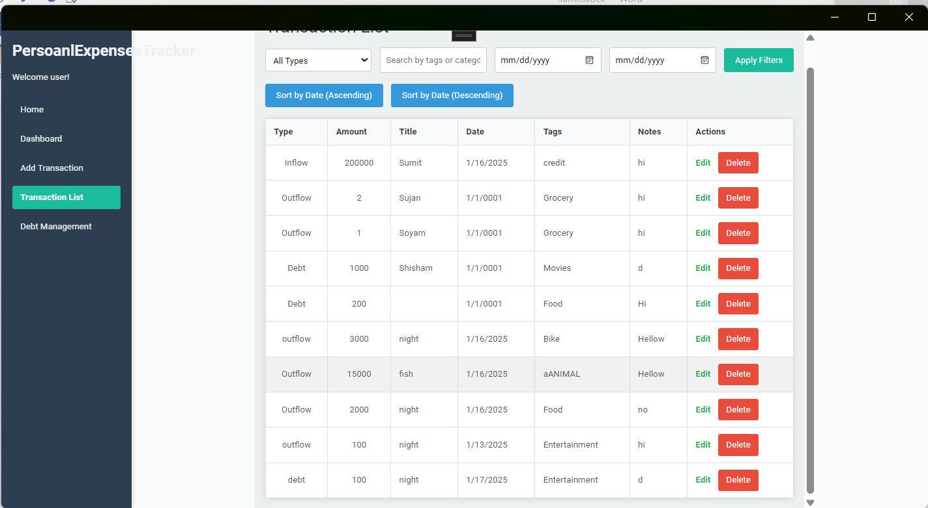

Figure 9:Click on edit button

Here, User can edit Transaction by clicking on edit.

## 2.9. After edit Transaction

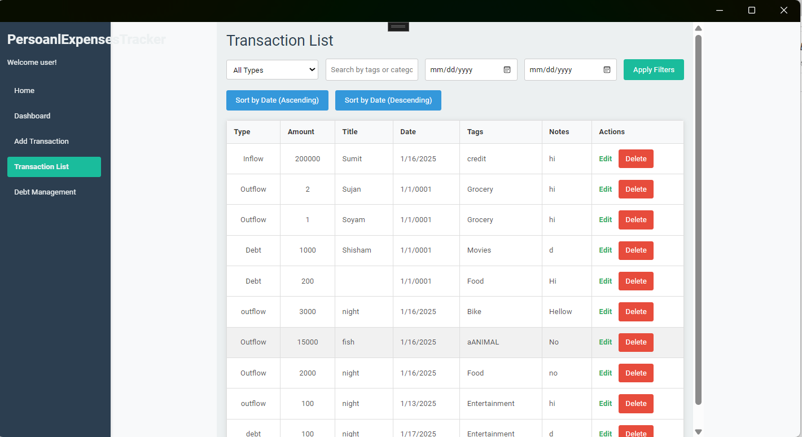

Figure 10:After edit Transaction

Here, User can see after edit Transaction.

## 2.10. Debt Management

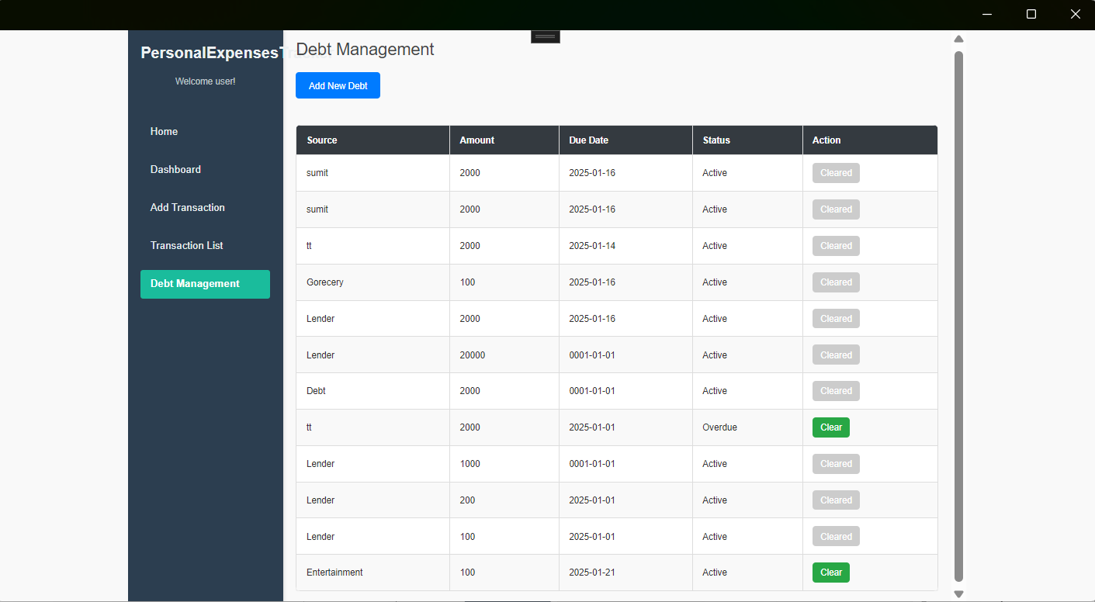

Figure 11:Debt Management list

Here, User can view Debt Transaction list, status, is debt is clear or not.

## 2.11. Add debt Transaction

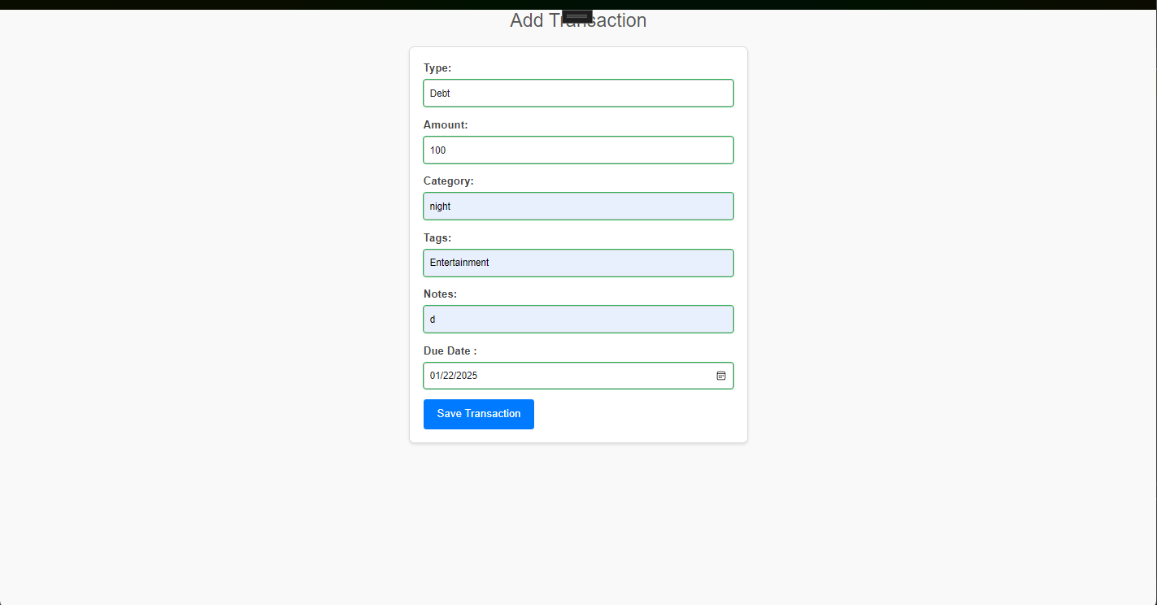

Figure 12:Add Debt Transaction

Here, User can add Debt Transaction by filling up Input field.

## 2.12. Dashboard Financial Summary

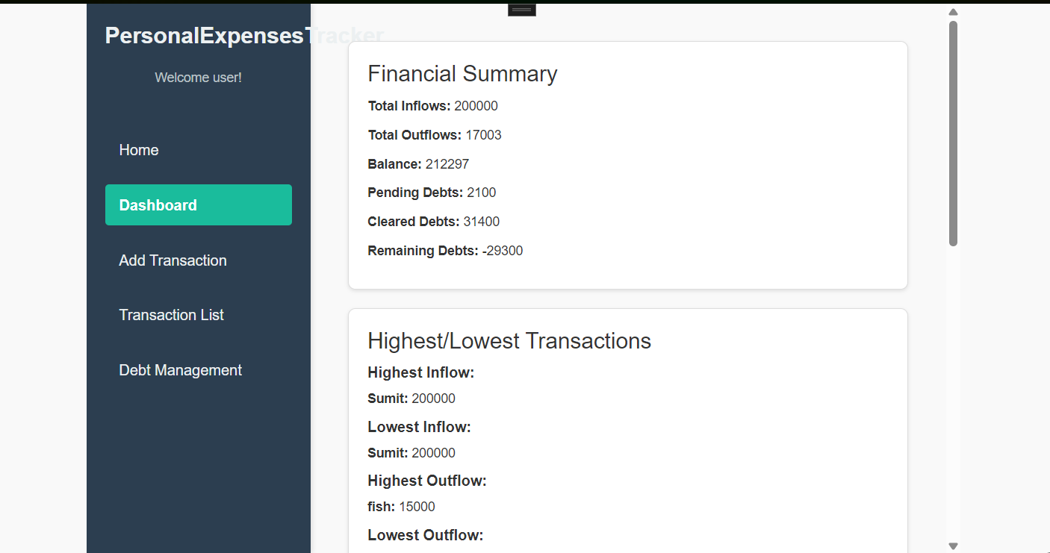

Figure 13:Dashboard Financial Summary

Here, User can view the Financial Summary of Expenses.

## 2.13. Highest/Lowest Transaction

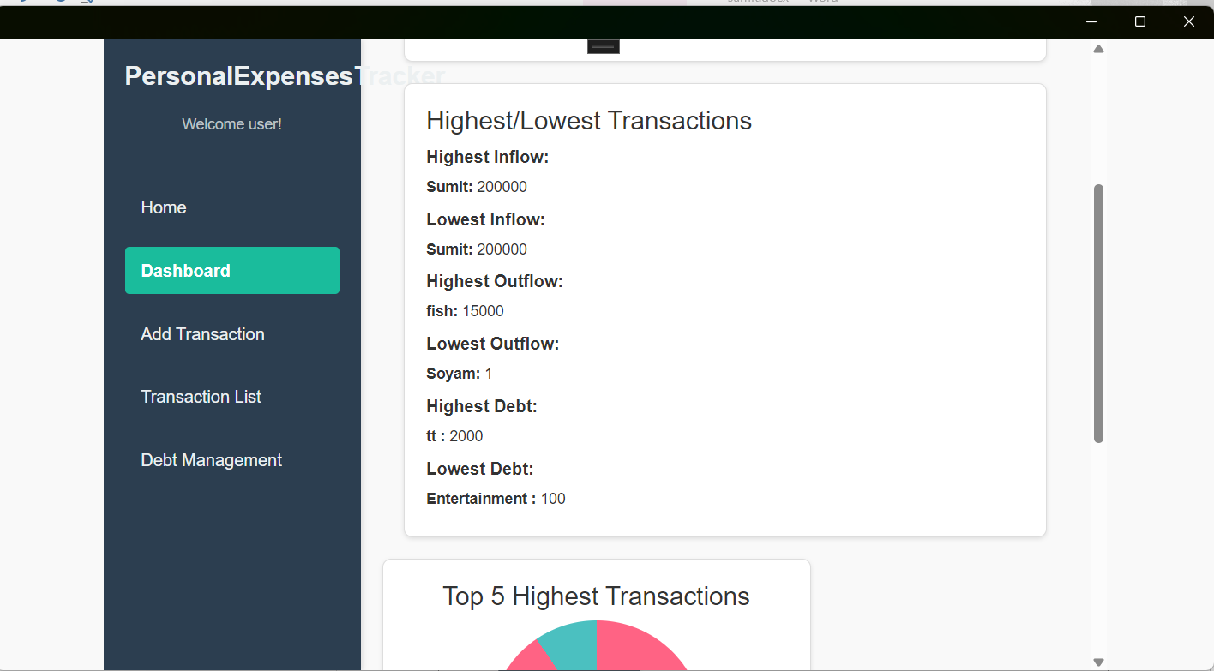

Figure 14:Highest/Lowest Transaction

Here, User can view Highest/Lowest Transactions by Title.

## 2.14. Top 5 Highest Transaction List and Piechart

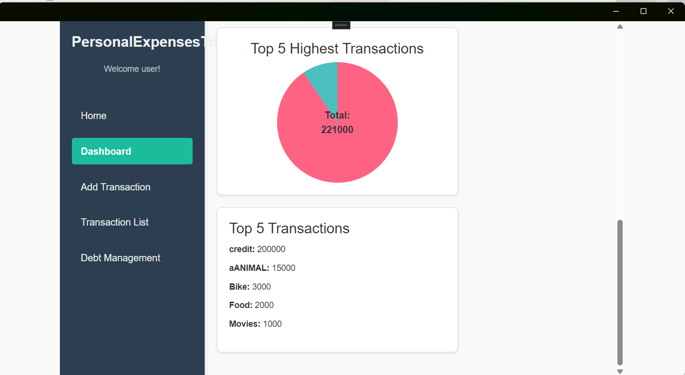

Figure 15:Top 5 highest Transaction

Here, User can see Top 5 Highest Transaction list by Tags.

# 3.Proof of Work (Pow)

## 3.1. GitHub

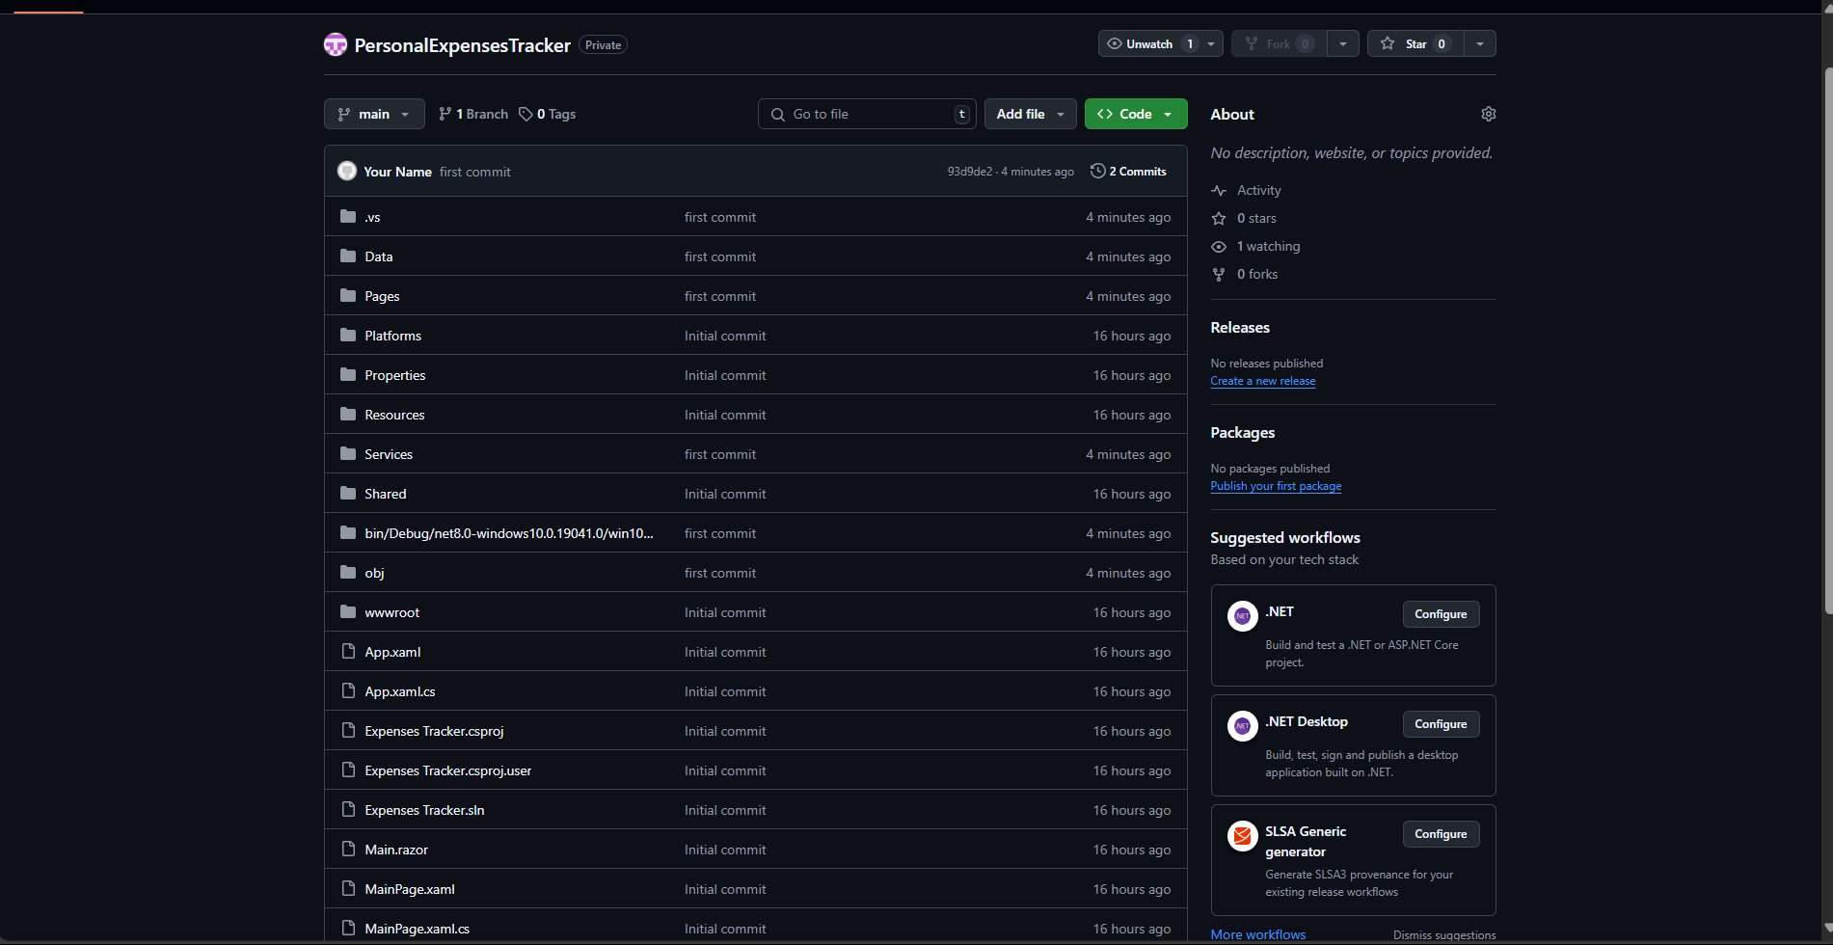

Figure 16:Github

## 3.2.ERD

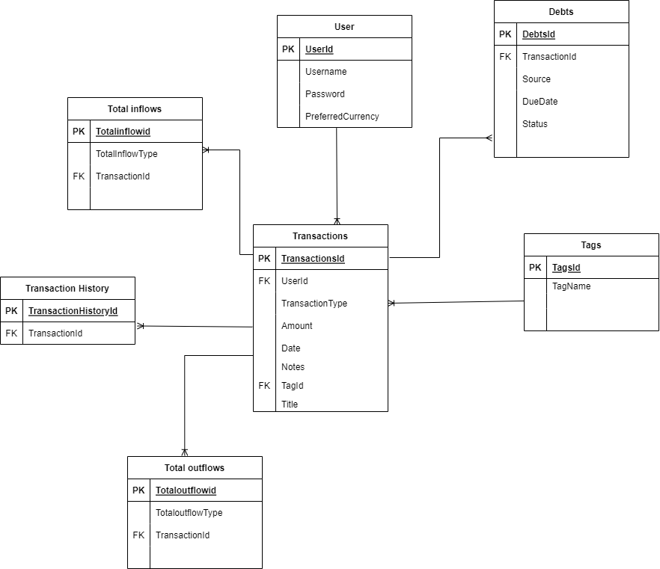

Figure 17:ERD

## 3.3. System Architecture

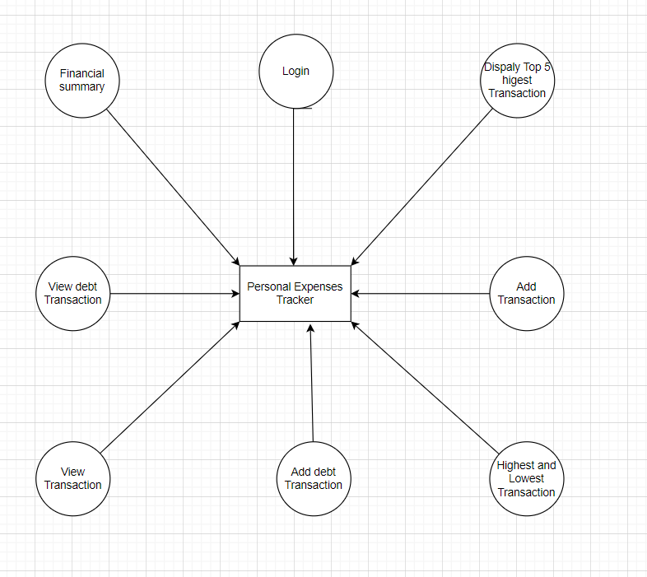

Figure 18:System Architecture

# 4.Individual Reflection(s)

The process of completing this course was challenging, beneficial, and helpful. A strong desire to learn and an urgent need to take action have always helped me accomplish my goals. The report, which I finished after much study and hard work, gave me a clear and practical understanding of C#. Understanding what it means took several days and nights since the ocean of C# is so deep that it is difficult to get in and lie down.

Since I was unfamiliar with the MAUI Blazor and the programming language, I first had trouble understanding the code. Getting to know MAUI Blazor and the programming language required a lot of work. I completed it with the help of the module teacher and a little research. Thanks to the C# abilities I obtained in the actual class, I was able to complete the coding portion. The most challenging and stressful part of the procedure, however, was the Json import. It was hard to understand. In addition to my employment advancement being hindered, my academic progress was also impeded. Thankfully, some research allowed me to address some of the issues. And I was able to resolve my problem after doing a lot of research. Going forward, I'm happy to report that I met all of my expectations because I had prepared the fundamental ideas before starting this coursework and received tutoring in addition to topic-related websites and videos that helped us identify our areas of weakness and tailor our learning. Ultimately, the effort is really rewarding. Being able to come up with fresh ideas, methods, and strategies for overcoming obstacles is something that is really special to me. Even while this assignment required me to develop a desktop application for a Personal Expenses, it also gave me the chance to learn more about it. It also assisted me in honing my analytical abilities. Despite the difficulties, I was able to overcome them, finish my assignment, and—most importantly—discover new things that expanded my knowledge and creativity with a little research and work. It made me realize that the ability to critically analyze and investigate is a necessary component of good innovation analysis.

# 5.Conclusion

The first course in this module, which makes up 30% of the module grade, is about creating a system for the Personal Expenses Tracker. Throughout the project's production, I heavily relied on books and online resources. A number of unexpected and novel flaws occurred, which alarmed me, but with enough effort and perseverance, I was able to overcome them. Additionally, I was able to learn and develop a wide range of skills that would help me through the challenges as part of the development system. I was successful in fully comprehending C#. I was sufficiently knowledgeable about creating desktop applications. I had the chance to study a new programming topic every day from the system's inception until its conclusion. The challenges help me have a deeper understanding of the language. Along with learning how to properly verify the system, I also learnt how to validate each of its smaller components independently. My future employment in information technology would greatly benefit from my proficiency with these programming languages and frameworks.